Laboratory #2 Report

Class:

Name: Student ID:

1. Exploration 1
2. Differential Gain

Table 2.1

|  |  |  |  |
| --- | --- | --- | --- |
| Freq. (Hz) | Vi,p-p (mV) | Vdo,p-p (mV) | Vdo,p-p / Vi,p-p (dB) |
| 20 | 200 |  |  |
| 100 | 200 |  |  |
| 1k | 200 |  |  |
| 10k | 200 |  |  |
| 20k | 200 |  |  |
| 30k | 200 |  |  |
| 40k | 200 |  |  |
| 50k | 200 |  |  |
| 100k | 200 |  |  |
| 200k | 200 |  |  |
| 500k | 200 |  |  |
| 700k | 200 |  |  |
| 1Meg | 200 |  |  |

1. Common-mode Gain

Table 2.2

|  |  |  |  |
| --- | --- | --- | --- |
| Freq. (Hz) | Vi,p-p (mV) | Vco,p-p (mV) | Vco,p-p / Vi,p-p (dB) |
| 20 | 200 |  |  |
| 100 | 200 |  |  |
| 1k | 200 |  |  |
| 10k | 200 |  |  |
| 20k | 200 |  |  |
| 30k | 200 |  |  |
| 40k | 200 |  |  |
| 50k | 200 |  |  |
| 100k | 200 |  |  |
| 200k | 200 |  |  |
| 500k | 200 |  |  |
| 700k | 200 |  |  |
| 1Meg | 200 |  |  |

1. CMRR Calculation

Table 2.3

|  |  |  |  |
| --- | --- | --- | --- |
| Freq. (Hz) | Gaindo,p-p (dB) | Gainco,p-p (dB) | Gaindo,p-p-Gainco,p-p (dB) |
| 20 |  |  |  |
| 100 |  |  |  |
| 1k |  |  |  |
| 10k |  |  |  |
| 20k |  |  |  |
| 30k |  |  |  |
| 40k |  |  |  |
| 50k |  |  |  |
| 100k |  |  |  |
| 200k |  |  |  |
| 500k |  |  |  |
| 700k |  |  |  |
| 1Meg |  |  |  |

1. Differential Gain with Extra Resistor Mismatch

Table 2.4

|  |  |  |  |
| --- | --- | --- | --- |
| Freq. (Hz) | Vi,p-p (mV) | Vdo,p-p (mV) | Vdo,p-p / Vi,p-p (dB) |
| 20 | 200 |  |  |
| 100 | 200 |  |  |
| 1k | 200 |  |  |
| 10k | 200 |  |  |
| 20k | 200 |  |  |
| 30k | 200 |  |  |
| 40k | 200 |  |  |
| 50k | 200 |  |  |
| 100k | 200 |  |  |
| 200k | 200 |  |  |
| 500k | 200 |  |  |
| 700k | 200 |  |  |
| 1Meg | 200 |  |  |

1. Common-mode Gain with Extra Resistor Mismatch

Table 2.5

|  |  |  |  |
| --- | --- | --- | --- |
| Freq. (Hz) | Vi,p-p (mV) | Vco,p-p (mV) | Vco,p-p / Vi,p-p (dB) |
| 20 | 200 |  |  |
| 100 | 200 |  |  |
| 1k | 200 |  |  |
| 10k | 200 |  |  |
| 20k | 200 |  |  |
| 30k | 200 |  |  |
| 40k | 200 |  |  |
| 50k | 200 |  |  |
| 100k | 200 |  |  |
| 200k | 200 |  |  |
| 500k | 200 |  |  |
| 700k | 200 |  |  |
| 1Meg | 200 |  |  |

1. CMRR Calculation with Extra Resistor Mismatch



Table 2.6

|  |  |  |  |
| --- | --- | --- | --- |
| Freq. (Hz) | Gaindo,p-p (dB) | Gainco,p-p (dB) | Gaindo,p-p-Gainco,p-p (dB) |
| 20 |  |  |  |
| 100 |  |  |  |
| 1k |  |  |  |
| 10k |  |  |  |
| 20k |  |  |  |
| 30k |  |  |  |
| 40k |  |  |  |
| 50k |  |  |  |
| 100k |  |  |  |
| 200k |  |  |  |
| 500k |  |  |  |
| 700k |  |  |  |
| 1Meg |  |  |  |

1. Problem 1

There is another important issue about the design of differential pair, which is the offset problem. The MOSFET differential pair in Fig.2.9(a) is suffered from the deviation of load resistanceΔRD, and the process deviation Δ(W/L), which is then resulted in VOS=f(ΔRD,Δ(W/L)). Other than that, Fig. 2.9(b), BJT differential pair is suffered from the similar problems, which are ΔRC and ΔIS. Explain that which configuration has better offset immunity. (Hint: in general, taking VOV as 100mV in MOSFET differential pair)

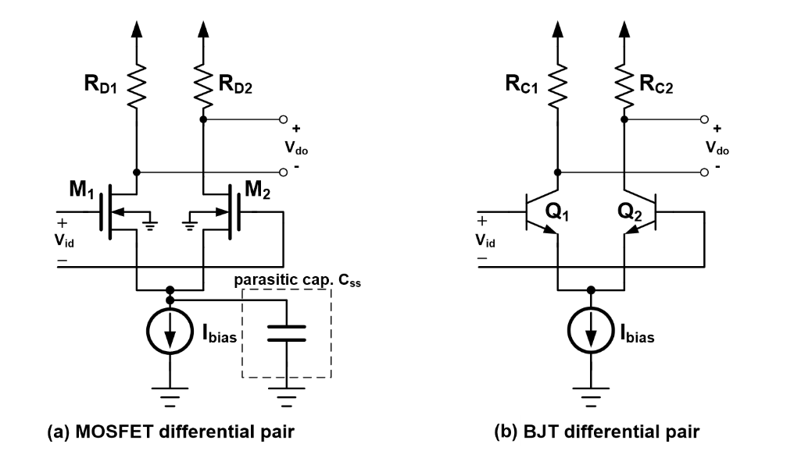

Fig. 2.11 (a) MOSFET (b) BJT differential pair

1. Problem 2

Use MATLAB or Excel to plot common-mode gain, differential gain and CMRR using measurement and calculation results respectively. Compare the differences between the differential amplifier with and without extra resistor mismatch. Also, list other possible mismatch sources during circuit design. (e.g. Resistor mismatch)

1. Bonus

Derive the transfer function of the common-mode gain of Fig. 2.3 (a), and explain how common-mode gain affects the performance of CMRR.

1. Conclusion