Laboratory #11 Pre-lab

Class:

Name: Student ID:

1. Explore the characteristics of Schmitt trigger.
2. Use PSpice to do the transient analysis on the circuit below.
   1. Apply a 5 Vpp sine wave with 1kHz at terminal *V3*.
   2. Show the waveforms of Vo versus Vi.



Vi

Vo

Fig. 11.15 Schematic of Schmitt trigger with inverting operation

1. Explore the characteristics of square-waveform oscillator
   1. Use PSpice to do the transient analysis on the circuit below, and show the waveform of V- versus Vo.



V-

Vo

Fig. 11.16 Schematic of square-wave oscillator with opamp

* 1. Remove the component U2, and do the transient analysis again. Please describe the difference between the output waveforms with and without U2.
  2. Use PSpice to do the transient analysis (transient time=10ms) on the circuit below, and show the waveform of Vo2

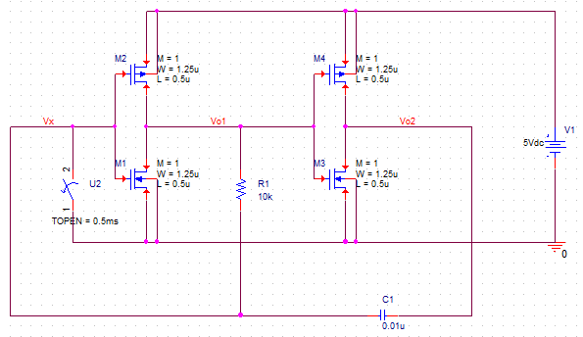

Fig. 11.17 Schematic of square-wave oscillator with inverter

* 1. Change R1 from 10kΩ to 100kΩ and explain the difference of Vo2 waveform.

1. Datasheet reading

Download the datasheet of DT26 (the website is listed in Ref [1]), then read and answer the following questions:

1. List several specifications related to stability and explain reasons.