Laboratory #1 Pre-lab

Class:

Name: Student ID:

1. Explore the frequency response of CS amplifier,
2. Use PSpice to do the ac analysis on the circuit below, and show the plot of frequency response of Vo/Vi (dB). Note that the NMOS model is NMOSOP5_BODY, and PMOS model is PMOSOP5_ BODY, which can be used when Sedra library is included. Schematic of the circuit is shown in Fig. 1.8 and the values of components’ parameters are all listed in Table 1.2.

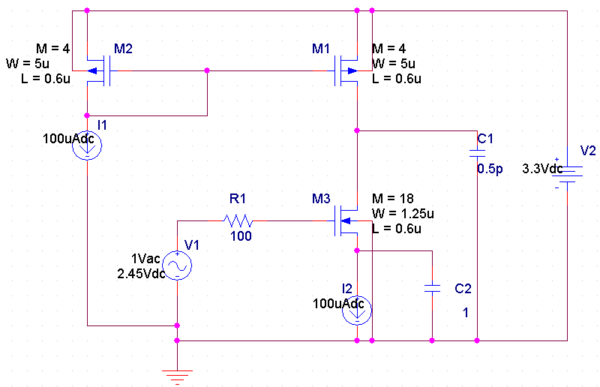

**Vi**

**Vo**

Fig. 1.8 Schematic of the CS amplifier for AC analysis

Table 1.2 Values of components’ parameters of the CS amplifier

|  |  |  |
| --- | --- | --- |
| Component | Spec. | |
| W/L (μm) | M |
| M1 | 5/0.6 | 4 |
| M2 | 5/0.6 | 4 |
| M3 | 1.25/0.6 | 18 |
| R1 | 100Ω | |
| C1 | 0.5pF | |
| C2 | 1F | |
| V1 | DC 2.45V with AC 1V | |
| V2 | DC 3.3V | |
| I1 | 100μA | |
| I2 | 100μA | |

1. Explore the frequency response of CS-CG folded-cascode amplifier,
2. To avoid the problem of limited operating range resulted from transistor stacking in cascode configuration. Folded-cascode is a more common topology in modern circuit design. By folding the PMOS down, DC gain remains the same as cascode configuration, but the input common-mode range has been improved. The circuit is as shown in Fig. 1.9.



Fig. 1.9 Schematic of the folded-cascode amplifier

**Vi**

Use PSpice to do the ac analysis on the circuit shown in Fig.1.10, and show the plot of frequency response of Vo/Vi (dB)

 Fig. 1.10 Schematic of the CS-CG cascode amplifier

**Vo**

1. Which of the transistor is operated as CG configuration, similar to the function of MP in Fig. 1.9?