Laboratory #2 Pre-lab

Class:

Name: Student ID:

1. Explore the CMRR of CMOS differential amplifier
2. Use PSpice to do the AC analysis on the circuit in Fig. 2.9. Show the plot of frequency response of Vdo/Vi (dB) and explain the result. Note that the frequency range is set from 100 Hz to 10 GHz, and resolution is set as 10 points per decade

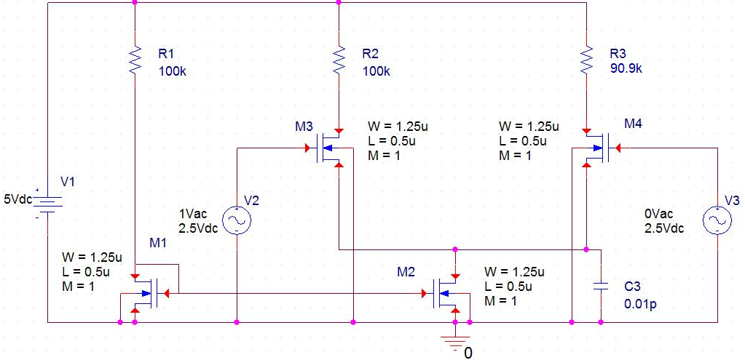

Vo-

Vo+

Fig. 2.9 Differential amplifier with differential input

Table 2.4 Values of components’ parameters of differential MOSFET amplifier

|  |  |  |
| --- | --- | --- |
| Component | Spec. | |
| W/L (μm) | M |
| M1 | 1.25/0.5 | 1 |
| M2 | 1.25/0.5 | 1 |
| M3 | 1.25/0.5 | 1 |
| M4 | 1.25/0.5 | 1 |
| R1 | 100kΩ | |
| R2 | 100kΩ | |
| R3 | 90.9kΩ (9.1kΩ mismatched value) | |
| C3 | 0.01pF | |
| V1 | DC 5V | |
| V2 | DC 2.5V AC1V | |
| V3 | DC 2.5V AC0V | |

1. Change the voltage source V3 into AC 1V as shown in Fig. 2.10. Use PSpice to do the ac analysis on the circuit below, and show the plot of frequency response of Vdo/Vi (dB).

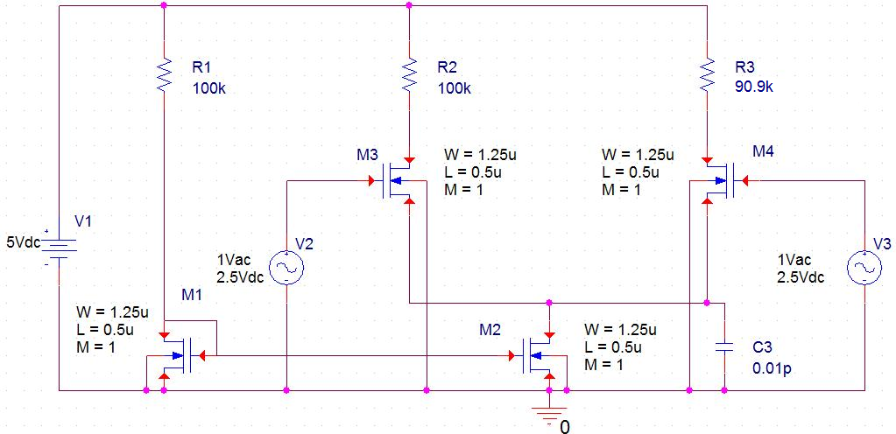

Vo-

Vo+

Fig. 2.10 Differential amplifier with common-mode input

1. Calculate the CMRR at input frequency = 1 kHz, 100kHz and

10 MHz.

1. Calculate the equivalent output resistance of M2 based on the frequency response of the common-mode gain.
2. Calculate the corner frequency of the common-mode frequency response if the C3 is changed to 0.1pF. Then verify the calculation result using PSpice.