Laboratory #3 Pre-lab

Class:

Name: Student ID:

1. Problem 1 (PSPICE simulation) Inverting OPAMP

Assemble the circuit as shown in Fig. 3.13 using LM324 OPAMP. The resistance values are R1=1kΩ, R2=10kΩ. Then, apply a sine wave at input node with 200mVpp amplitude and 1 kHz frequency. Plot the waveforms at input and output terminals and explain the result.

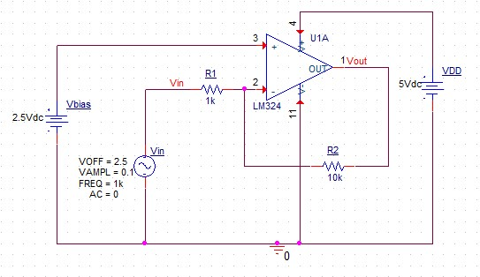

Fig. 3.13 Inverting OPAMP

1. Problem 2 (PSPICE simulation) Non-inverting OPAMP

Assemble the circuit as shown in Fig. 3.14 using LM324 OPAMP. The resistance values are R1=1kΩ, R2=10kΩ. Then apply a sine wave at input node with 200m Vpp amplitude and 1 kHz frequency. Plot the waveforms at input and output terminals and explain the result.

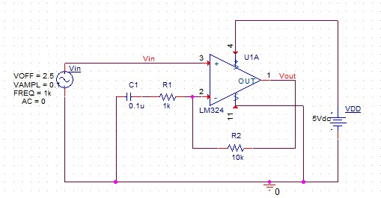

Fig. 3.14 Non-inverting OPAMP

1. Problem 3 (PSPICE simulation) OPAMP Integrator

Assemble the circuit as shown in Fig. 3.15 using LM324 OPAMP. The resistance values are R=1kΩ, C=0.1μF. Then apply sine wave at input node with 200mVpp amplitude and 1 kHz frequency. Plot the waveforms at input and output terminals and explain the result.

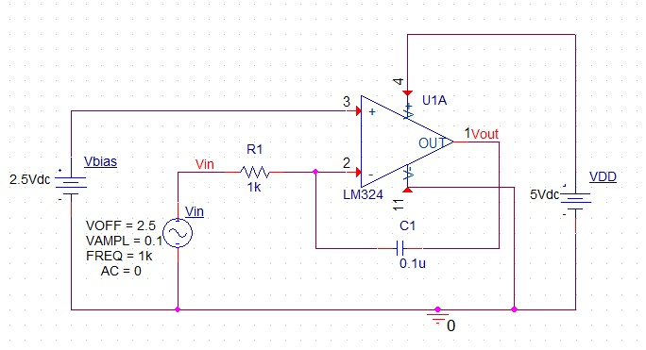

Fig. 3.15 OPAMP integrator

1. Problem 4 (PSPICE simulation) OPAMP differentiator

Assemble the circuit as shown in Fig. 3.16 using LM324 OPAMP. The resistance values are R=1kΩ, C=0.1μF. Then apply sine wave at input node with 200mVpp amplitude and 1 kHz frequency. Plot the waveforms at input and output terminals and explain the result.

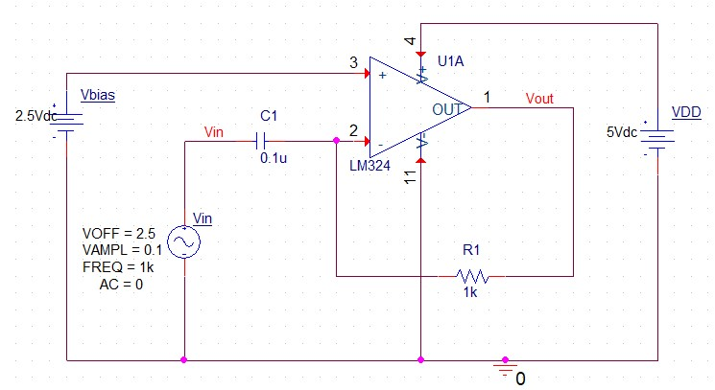

Fig. 3.16 OPAMP differentiator

1. Problem 5 (Term explanation)

Explain the following terminologies:

1. 3-dB bandwidth
2. Gain margin
3. Phase margin
4. CMRR
5. PSRR