Laboratory #6 Pre-lab

Class:

Name: Student ID:

1. Explore the transfer curve of CMOS OPAMP
2. Use PSpice to do the DC analysis on the circuit in Fig. 6.13, set the aspect ratio (W/L) of PMOS to 3/0.5 (μm) and 1/0.5 (μm) for NMOS. Both of the NMOS and PMOS can be found in SEDRA_LIB of Pspice (NMOSOP5_BODY and PMOSOP5_BODY). Plot the figure of the input-output transfer curve, and write down the threshold voltage by using the definition in page 3.

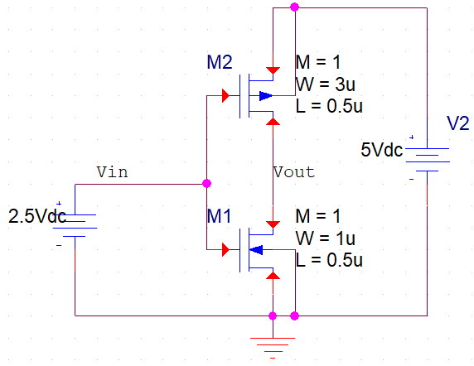

Fig. 6.13 Schematic of the CMOS OPAMP in PSpice

1. Change WM2/WM1 into 3/3(μm) and WM2/WM1=6/1(μm) with the same channel length (0.5μm), and show the transfer curve respectively. Compare the transfer curves under two different conditions and explain the reasons for the movement of the threshold voltage.
2. Explore the transfer curve of CMOS OPAMP with feedback resistor
3. Use PSpice to do the DC analysis on the circuits in Fig. 6.14 (a), set the aspect ratio (W/L) of PMOS to 3/0.5 (μm) and 1/0.5 (μm) for NMOS. Then connect a resistor with 1MegΩ as shown in Fig. 6.14(a). Plot the input-output transfer curve of this circuit and write down the threshold voltage.

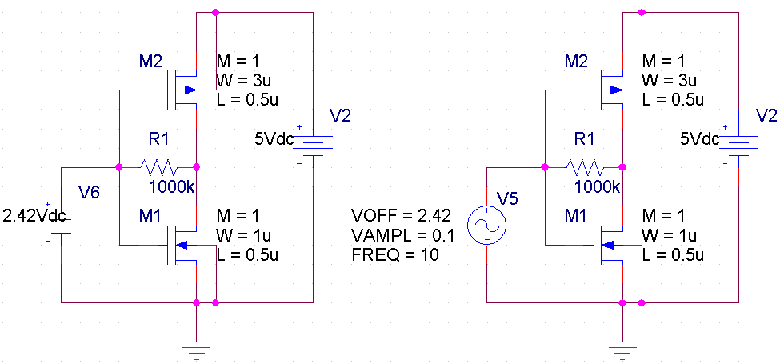

1. (b)

Fig. 6.14 (a) DC analysis of the OPAMP with feedback resistor, (b) time domain analysis of the OPAMP

1. Change the resistor to 1K in Fig. 6.14 (a) and compare the threshold voltage in (1). Please explain the simulation result
2. Please use the circuit in Fig. 6.14 (a) and write down the threshold voltage. Change the input voltage source into VSIN and set the amplitude to 0.1V and frequency to 10Hz as Fig. 6.14 (b). Does the gain (amplitude of Vout/amplitude of Vin) match to the transfer curve? If the output signal amplitude does not match to the transfer curve, why? (Hint: please change the frequency of input signal, and briefly explain the reason for the differences of the output signal)
3. Explore the open-loop frequency response of Fig. 6.15

(1)

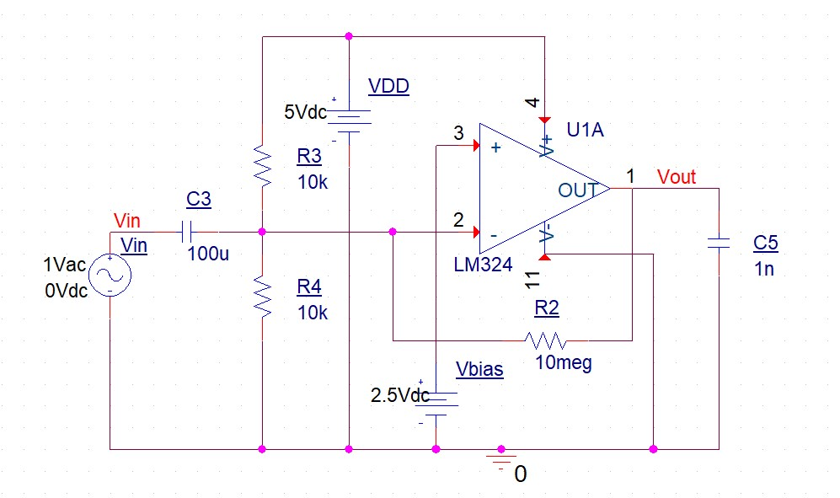

Fig. 6.15 Open-loop gain measurement of LM324

In exploration 3, please use LM324 (in Library “EVAL”) as the OPAMP, R2 = 10Meg, R3 = R4 = 10k and C3 = 100μF, C5 = 1nF is equivalent to the load capacitance. Use the AC source (VAC=1V) for sweeping the input signal and plot the frequency response.

(2) Record down the open-loop gain and the 3dB pole frequency. The open-loop gain (Aopen) = (dB), ω3dB,o= (Hz)

1. Explore the closed-loop frequency response of Fig. 6.16

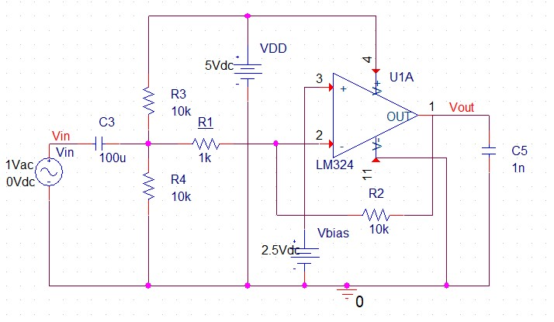

Fig. 6.16 Inverting configuration of LM324

In exploration 4, please use inverting configuration, set R2 = 10k and R1 = 1k. Use the AC source (VAC=1V) for sweeping the input signal and plot the frequency response.

1. Record down the closed-loop gain and the 3dB pole frequency. The closed-loop gain (Aclose) = (dB), ω3dB,c= (Hz)
2. Estimate the open-loop gain (Aopen,est) with the result in exploration 4. The relationship between the closed-loop gain (Aclose) and the open-loop gain (Aopen,est) will be as follow.



Please calculate the open-loop gain, Aopen,est = (dB)

Is Aopen in exploration 3 close to Aopen,est in exploration 5? Why?