Laboratory #7 Pre-lab

Class:

Name: Student ID:

1. Explore the frequency response of the first-order low-pass filter,
2. Use PSpice to do the ac analysis on the circuit below, and show the plot of frequency response of Vo/Vi (dB)

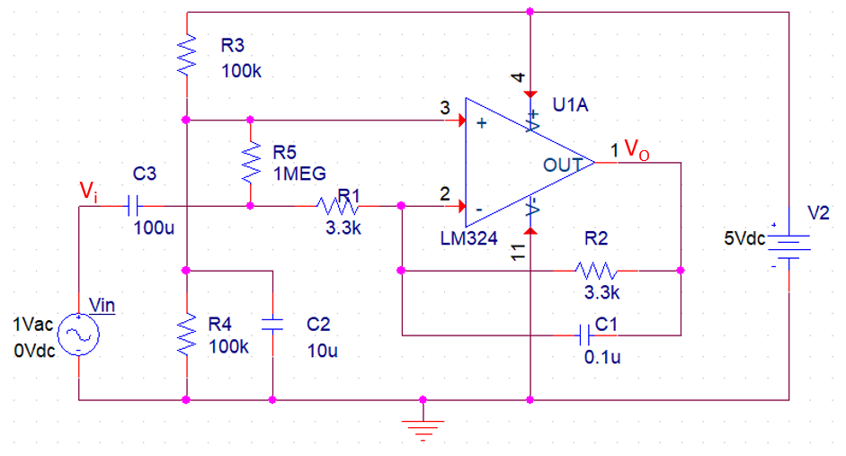

Fig. 7.8 Schematic of the first-order low-pass filter for AC analysis

1. Change C1 from 0.1μF to 1μF and 10μF respectively, and show the plot of frequency response of Vo/Vi (dB).
2. Explain the relationship between the capacitor C1 and the 3-dB frequency.
3. Explore the frequency response of first-order high-pass filter,
4. Use PSpice to do the ac analysis on the circuit below, and show the plot of frequency response of Vo/Vi (dB)

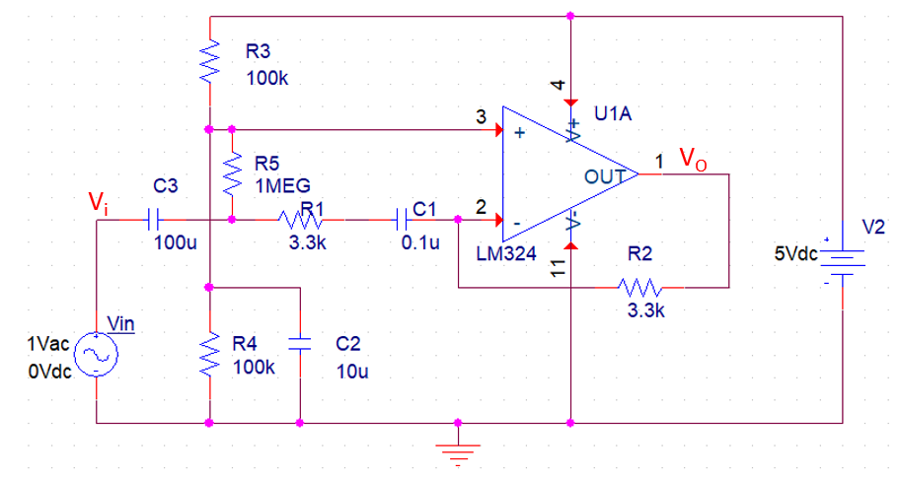

Fig. 7.9 Schematic of the first-order high-pass filter for AC analysis

1. Change C1 from 0.1μ to 1μ and 10μ respectively, and show the plot of frequency response of Vo/Vi (dB)
2. Explain the relationship between the capacitor C1 and the 3-dB frequency.
3. Explore the frequency response of second-order low-pass filter,
4. Use PSpice to do the ac analysis on the circuit below, and show the plot of frequency response of Vo/Vi (dB).



Fig. 7.10 Schematic of the second-order low-pass filter for AC analysis

1. Change C1 and C2 from 0.01μ to 1μ and 10μ respectively, and show the plot of frequency response of Vo/Vi (dB)
2. Explain the relationship between the capacitor (C1 and C2) and the 3-dB frequency.
3. Explore the frequency response of second-order high-pass filter
4. Use PSpice to do the ac analysis on the circuit below, and show the plot of frequency response of Vo/Vi (dB).



Fig. 7.11 Schematic of the second-order high-pass filter for AC analysis

1. Change C1 and C2 from 0.01μ to 1μ and 10μ respectively, and show the plot of frequency response of Vo/Vi (dB)
2. Explain the relationship between the capacitor (C1 and C2) and the 3-dB frequency.